
South Pembrokeshire Golf Club

Press Report

South Pembs make a good start to the new season
April saw the start of inter-club competition at South Pembrokeshire Golf Club, with the Tigers taking on Newport Links at home. Despite many of the Tigers regulars being unavailable, they managed to secure a 4½ points to 3½ win on Saturday, in their return to the second division. The Seniors hosted Cardigan on Wednesday 11th in the South Wales Seniors Classic competition. This is a fourball competition for three pairs per team, and the 2½ to ½ result sees South Pembs go on to the second round of the trophy. Darrell Willington and Mike Williams led off, and set the pace with a win. The second match was tighter and Jeff Teague and Geoff Cole held off their opponents to secure a creditable half on the 18th. The final match was more one sided, with Peter Johnson and Harley Chessell sealing the overall match win 5 & 4.

In the Daily Mail Foursomes, South Pembs' representatives Andrew Morrissey and Gary Sharp achieved a 4 and 2 win against Haverfordwest, to go through to the next round of this prestigious national foursomes competition.

The Rabbits team, meanwhile, faced with four away fixtures in April have been unable to overcome Milford Haven GC and Ashburnham so far. However the team is looking strong and no doubt will deliver the goods soon.

Seniors Away Day at Swansea Bay Golf Club.
Twenty six of the Seniors travelled to Swansea in dry, relatively calm conditions, to play a damp but enjoyable course, where the greens were the highlight of a very enjoyable outing. The group were given a warm welcome and very good hospitality at this historical venue.
The course was a mix of links and meadow holes, surrounded by woodland, with some challenging terrain. So the players were put on their metal as they took on the challenge of this interesting eighteen hole challenge.
The Prize winners were as follows, in Category 1 (H’caps 0-19) the Winner was Darrell Willington (33pts), second Martin Lewis (30pts) and third Ken Smith (25pts); Category 2, (H’caps 20+) winner was Harold James (29pts), second John Parsons who pipped Kevin Dewhurst on the better back nine, both scoring 28pts. Nearest the pin on a tough 17th hole was Terry Watkins with a marvellous drive, although he failed to secure a two. The two’s competition was won by Nigel Williams, with a miraculous, “flukey” he said, thirty foot putt on the seventeenth. The Best Endeavours award went to Cliff Jackson on his first Seniors away day. Well done to all, who thanked Mike Bradney profusely for organising the whole day.
The next away day is on July 16th, when the Seniors will be travelling to Pontardawe G.C.

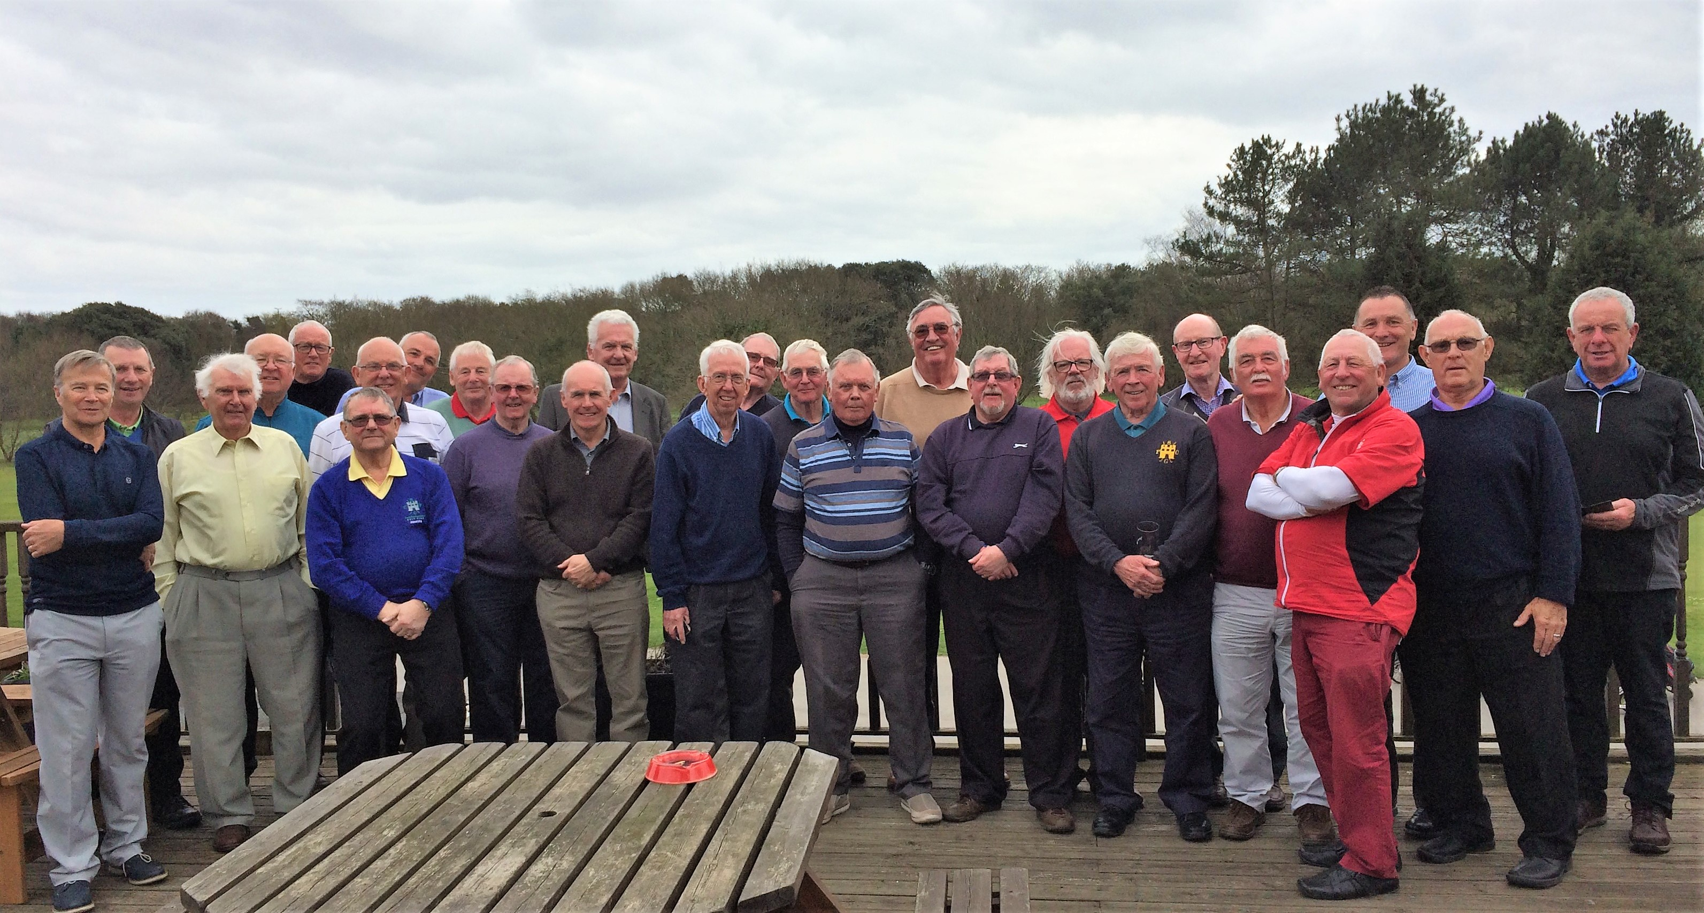

Future Competitions etc.

Members and Guest Day sponsored by “The Energy Check” – this is scheduled for Saturday 5th May, with prizes available for individual gents and ladies, plus a team prize for the best member/guest partnerships. More space is available so get your names down now. There is music in the evening from Tony Cash, together with prize presentation, and food through the day.

Mike Swain and Darrell Willington

